

**FLAPPY BIRD**

**Team Name: The Brainy Fools**



January 15, 2019

**Project Mentor: Team Members :**

**Falguni Roy 1.Md Al-Adnan(08)**

**Lecturer 2.Moonmoon Das(27)**

**IIT,NSTU 3.Akash Debnath(37)**

**1. Overview**

**1.1 Introduction:**

This is a proposal for software project lab I. This project will be developed during the **3rd semester of** **BSSE 1st Batch, IIT, NSTU,** from *January 2018* to end of the semester and the final project will be delivered at *March 2018*. We hope, we will give the half work presentation during the *second week* *of February* as directed. We will work along with our regular academic courses. This project is the implementation part of the course **Software Project Lab - I**.

**1.2. Title:**

Flappy Bird.

**1.3. Motivation:**

Playing games on PC or Desktop is a very excellent way of passing leisure. Various games are available today. Flappy Bird is a popular game among children in Bangladesh. Previously Nokia 1210 model mobile gives scope to play this game which was not available at any other mobile phone. As new android mobile are available in our local market, the previous version of Nokia will be vanished. That’s why we wanted to implement this game on Desktop. We hope, people will get themselves entertained playing this game with in Desktop or PC version. It is a game of expertness.

**1.4. Objectives:**

Through this project our goal is to learn-

* **User** :
* Entertainment.
* Be more diligent.
* **Developer** :
* Competent OOP using JAVA.
* Graphics.
* To Work in a group.
* To create desktop-application.

**1.5. Scope:**

* This game will be available on Desktop and PC version.
* Later version may be developed for Android.

**2. Project Delivery:**

**2.1. Game Description:**

* We plan on creating a 2D version of Flappy Bird.
* The bird will be moving forward continuously between sets of pipes.
* The bird jumps up a small amount whenever the spacebar is pressed and can move to the left or right using the left and right arrow keys.
* If the bird collides with a pipe, the ground, or the ceiling, then the game is over. The pipes will have a random size and be created in random locations.
* If any player navigates between each pair of pipes, the player earn a single point.
* Player score will be tracked throughout the level.

**2.2 Deliverables:**

**i.** Source code

**ii.** Documentation

**iii.** User Manual

**2.3 Work Distribution:**

|  |  |
| --- | --- |
| **Task** | **Active Member** |
| ***Proposal*** | *Md Al-Adnan, Moonmoon Das, Akash Chandra Debnath* |
| ***Requirement Analysis, Specification*** | *Md Al-Adnan, Moonmoon Das, Akash Chandra Debnath* |
| ***Design*** | *Md Al-Adnan, Moonmoon Das, Akash Chandra Debnath* |
| ***Study*** | *Md Al-Adnan, Moonmoon Das, Akash Chandra Debnath* |
| ***Coding*** | *Md Al-Adnan, Moonmoon Das, Akash Chandra Debnath* |
| ***Final Testing*** | *Md Al-Adnan, Moonmoon Das, Akash Chandra Debnath* |

**2.4 Proposed Time line:**

|  |  |
| --- | --- |
| **Task** | **Deadline** |
| ***Proposal*** | *Within 3rd week of January* |
| ***Requirement Analysis, Specification*** | *Within 21th January* |
| ***Designing, Study*** | *Within 28th January* |
| ***Coding*** | *Within 24th February* |
| ***Final Testing*** | *Within 3rd March* |

**2.5 Time Scale:**

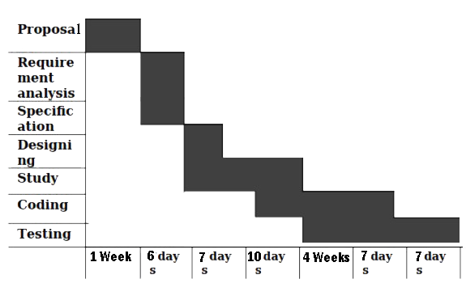

**3. Summary:**

It is very interesting to play our own developed game. It is more interesting to watch anyone else playing our own game. We hope, Flappy Bird will be more popular game among children in Bangladesh.

**4. Requirements:**

No specific OS is needed. People need a desktop and PC to enjoy this game.

**5. Reference:**

Text- I. Java How to Program by Deitel

II. Java the Complete Reference by Herbert Schildt

Web resources-

* [https://www.wikipedia.org/flappybirds](https://www.wikipedia.org/)
* <https://mashable.com/2014/02/10/flappy-bird-story/>
* <https://www.wired.com/2014/02/flappy-bird/>